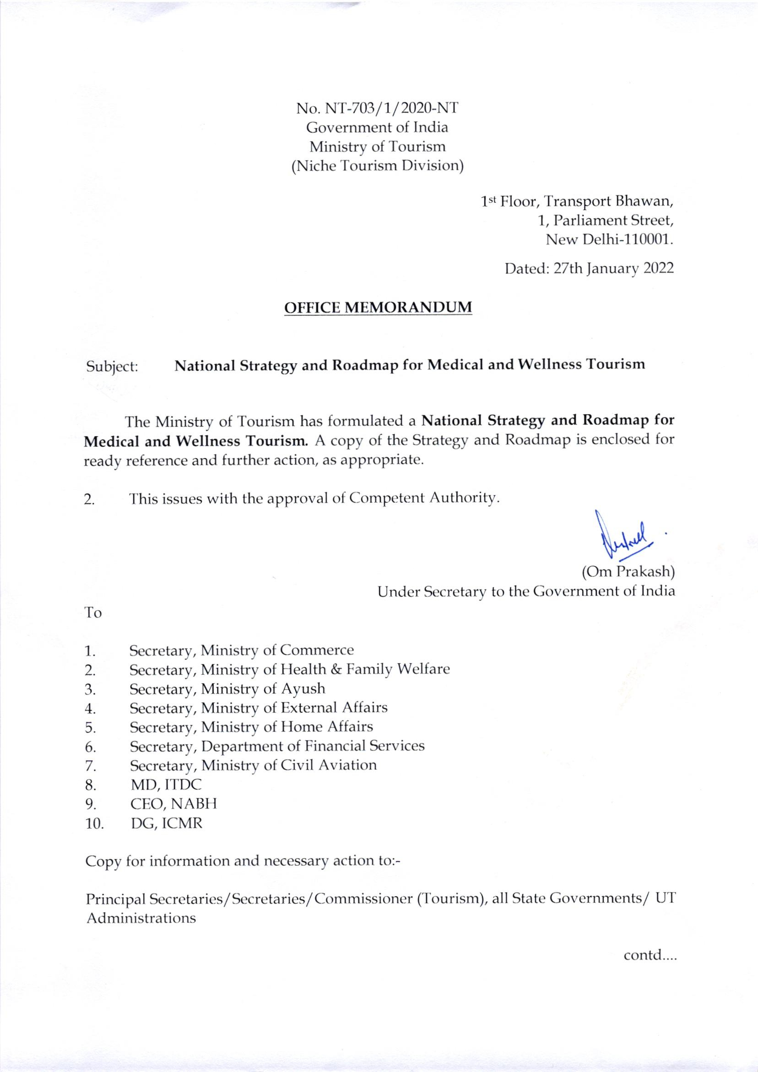

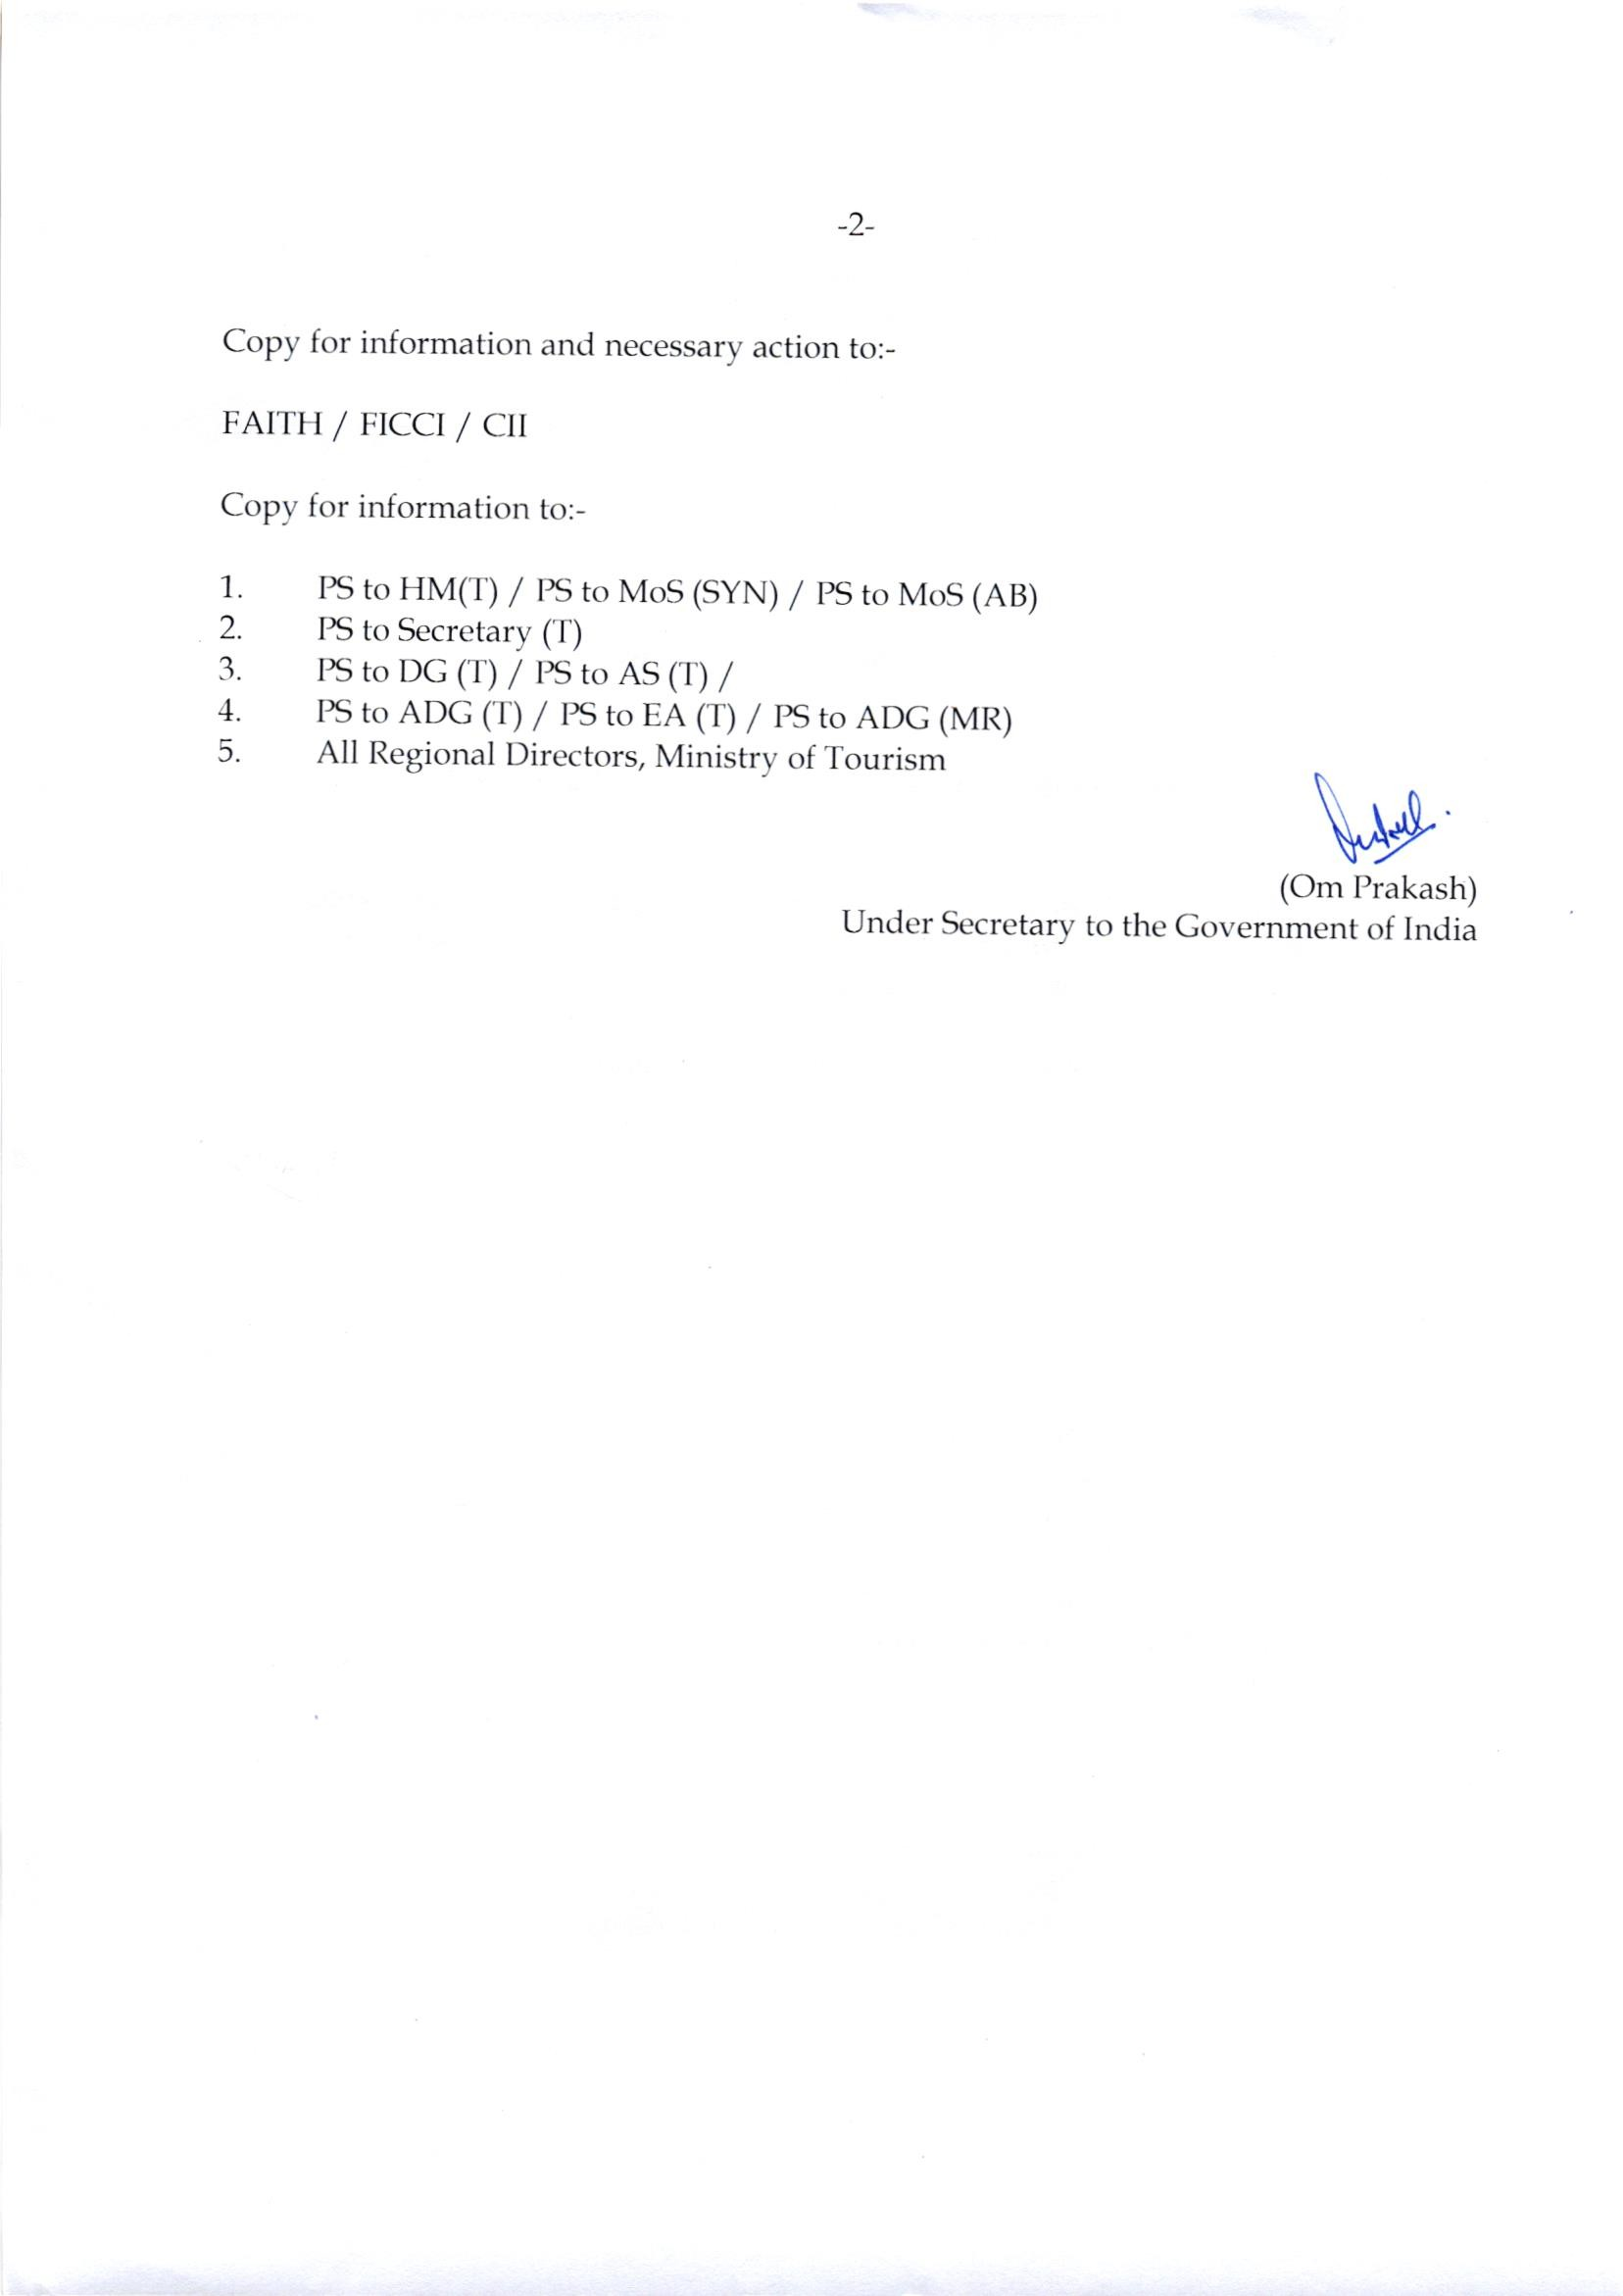

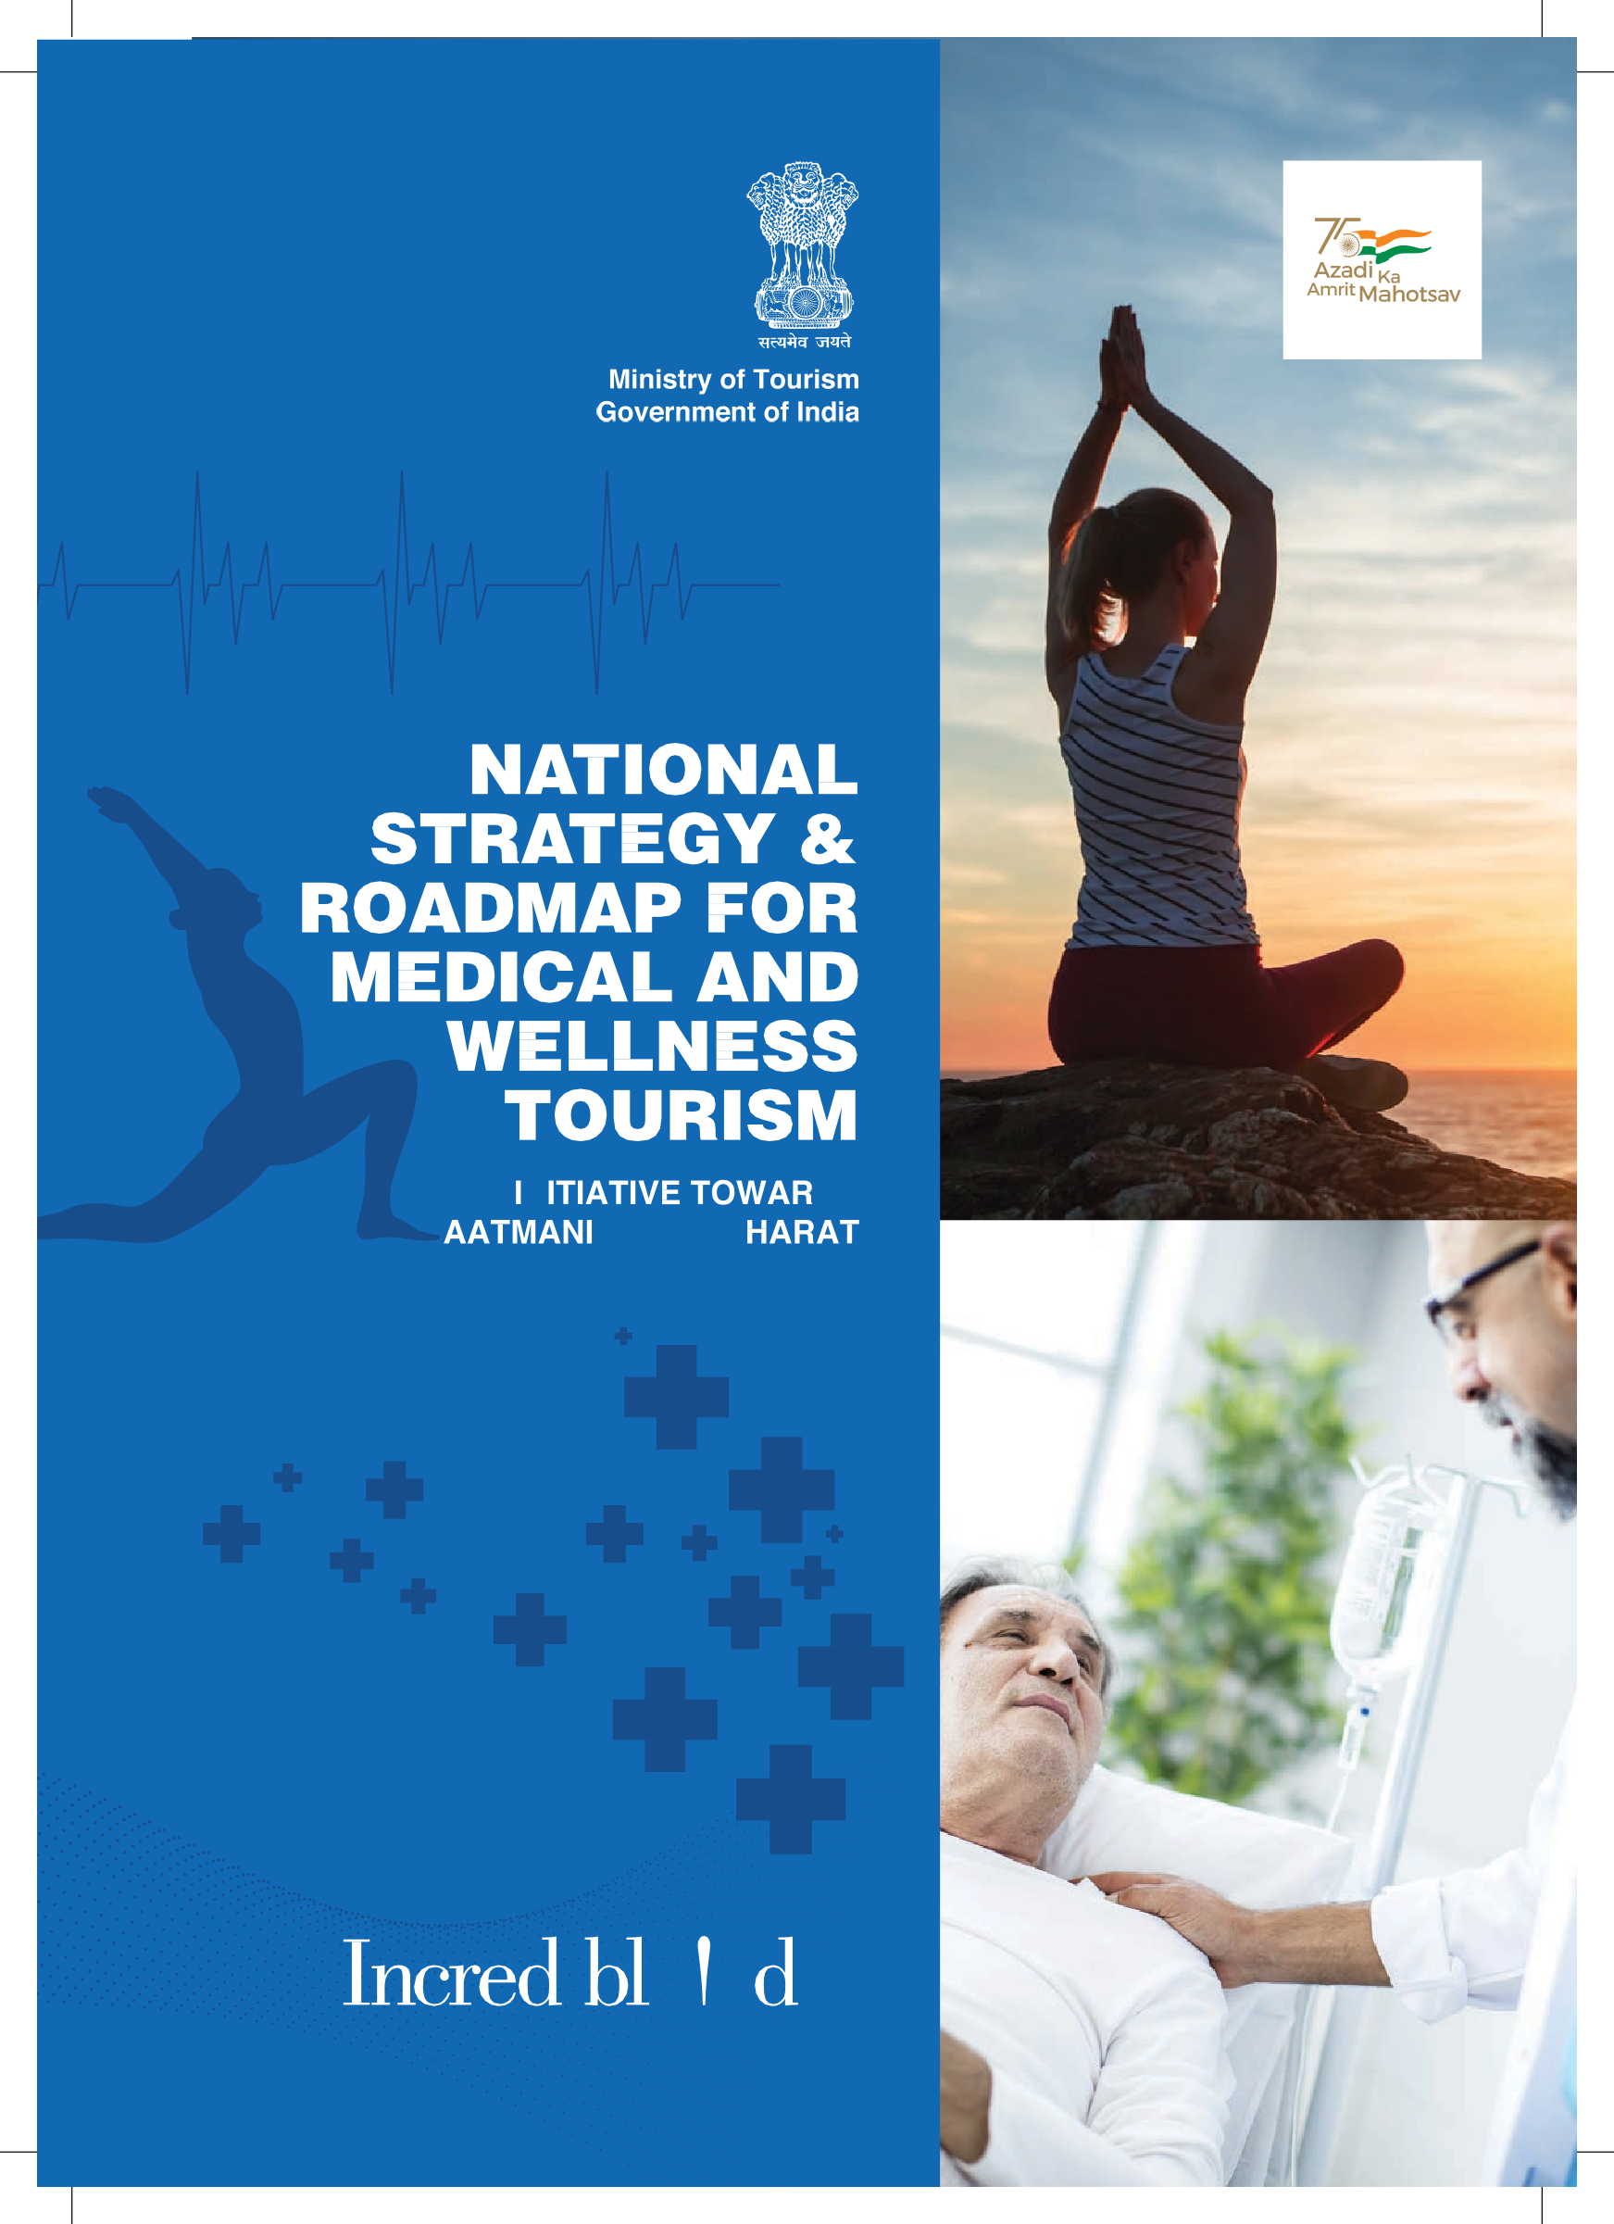  1











2











4



5









6



* 1. Medical Tourism 02

7



* 1. Wellness Tourism 02
  2. Medical Tourism vs. Wellness Tourism 03
  3. Medical Value Travel and Wellness Tourism – A Global Opportunity 03
  4. India as a destination for Medical Value Travel & Wellness Tourism 04
  5. National Strategy for Medical Value Travel and Wellness Tourism 05
  6. Swot Analysis 08
  7. Challenges in Wellness Industry 11
  8. Stakeholders 12
  9. Vision 18
  10. Mission 18
  11. Key Strategic Pillars 18
  12. Need for a brand for India as a Wellness Destination 22
  13. “Heal in India” brand for promoting India as Wellness Tourism Destination 22
  14. Partnership with Indian Missions 23
  15. Corporate arrangements with Foreign Governments 23
  16. Attracting Diaspora 23
  17. Marketing Development Assistance 23
  18. Need for strengthening the Ecosystem 26
  19. Organizing Medical Value Travel Facilitators 26
  20. Developing NABH Standards and Accreditation for Dental Clinics 27
  21. Telemedicine as a Focus Area 27
  22. Health Insurance Portability 27
  23. Developing Medical Enclaves for Foreign Patients 28
  24. Developing Special Wellness Tourism Zone 28
  25. Organizing Medical Service Providers 28
  26. Organizing Wellness Tourism Operators 29
  27. Capacity Building of Enterprises and Staff 29
  28. State and Destination Assessment for MVT and Wellness Tourism 30
  29. MVT Portal – One Stop Solution to facilitate International Patients 34
  30. Main features of the Portal 34
  31. Advantages of Online MVT Portal 35
  32. Liberalized Visa Policy 38
  33. Better Air Connectivity 38
  34. Helpdesk and MVT Lounge at the Airport 38
  35. Every Destination has something unique to offer to Wellness Travellers 42
  36. Convergence of Wellness, Hospitality and Travel Businesses 42
  37. Focus on North East Region 43
  38. Government support for Tourism Wellness Companies 44
  39. Quality Assurance System for Wellness Tourism 44
  40. National Medical & Wellness Tourism Promotion Board (NMWTB) 48
  41. The board to be a dedicated agency for Medical and Wellness Tourism 48
  42. The board to be restructured to include all Stakeholders 49
  43. State Medical and Wellness Tourism Promotion Board 50
  44. Action Plan 50

8



01



CH AP T E R

 





02



Medical tourism may be defined as ‘activities related to travel and hosting a foreign tourist who stays at least one night at the destination region for the purpose of maintaining, improving or restoring health through medical intervention’

Such medical intervention may be broadly classified into following three categories:



Treatment for curative purposes may include cardiac surgery, organ transplant, hip and knee replacement etc.



Offerings focused on rejuvenation or for aesthetic reasons such as cosmetic surgery, stress relief, spas etc.



Access to traditional systems of medicines such to as India’s offering of AYUSH (Ayurveda, Yoga & Naturopathy, Unani, Siddha and Homeopathy).

Medical tourism is now often referred to as     as it captures patients’ healthcare-seeking behaviour as well as the wider economic impact of such travel on nations hosting them.



Global Wellness Institute has defined wellness tourism as “travel associated with the goal of maintaining or enhancing one’s personal well-being and includes the pursuit of physical, mental, spiritual or environmental ‘wellness’ while traveling for either leisure or business.”

03

by wellness.

A traveller whose trip or destination choice is primarily motivated

A traveller who seeks to maintain wellness while traveling or



who participates in wellness experiences while taking any type of trip for leisure or business.





Wellness tourism is often clubbed with medical tourism but wellness tourism is not medical tourism. Some overlap notwithstanding, the two sectors, operate largely in separate domains and meet different consumer needs.

Medical tourism primarily addresses the “poor health” end of the market, with patients traveling to another place for specific medical treatments or enhancements. Top medical tourism procedures include cosmetic surgery, orthopaedic surgery, cardiac surgery, and dental procedures. Patients and their families are attracted by the availability, better quality, and/or price of care at the destinations. Therefore, successful medical tourism depends upon the status of a country’s broader medical sector, along with appropriate government regulations, patient safeguards, training standards, insurance frameworks, travel and visa restrictions, and other issues that drive the patient’s experience and treatment outcomes.

Wellness tourism, on the other hand, attracts consumers who are at the opposite end of the wellness continuum — those seeking activities and destinations that extend their wellness lifestyle and help them proactively maintain and improve their health and wellbeing. The appeal and success of wellness tourism depends on an entirely different set of factors, business models, customer mindsets, human resources, and industry culture, and it is more closely aligned with leisure, recreation, and hospitality.



Healthcare and Tourism are the fastest growing industries in the world. Medical Value Travel is being promoted as a fusion product of these industries. Medical Value Travel has grown across the globe and numerous possibilities still remain unexplored. The key drivers of the growth of MVT are:





Thailand, Mexico, US, Singapore, India, Brazil, Turkey, and Taiwan are the top destinations in terms of the number of patients for Medical Value Travel. The global medical value travel market size is in the range of USD 60-80 Billion and some 14 million people travel across the borders for medical tourism1.

1 There is wide variation in the estimates for market size and number of people undertaking medical value travel due lack of standard definitions and lack of robust mechanisms for data collection

04 

India has been ranked 10th in Medical Tourism Index (MTI) for 2020-21 out of 46 destinations of the world by Medical Tourism Association.

Global Wellness Institute has estimated the global wellness tourism market to be USD 639 Billion in 2017 with Secondary wellness travellers accounting for 89% of the trips and 86% of the expenditure. Domestic wellness travel contributing 82% of total trips and 65% of expenditure.

United States, Germany, China, France, Japan, Austria and India are the leading countries for wellness tourism in terms of the size of wellness tourism market.





Over the years, India has grown to become a top-notch destination for medical value travel because it scores high over a range of factors that determines the overall quality of care. The high-end healthcare system in India is as good as the best in the world. Complex surgical procedures are done in a world-class global hospital by acclaimed medical specialists at a much lower cost than what it normally takes in other countries.

India has also become a favoured destination for Yoga and Wellness with its focus on traditional therapies through AYUSH.

The number of international patients increased from 4.3 lacs in 2016 to 7 lacs in 2019 with an estimated market size in the range of USD 5-6 Billion for 2019.

Southern and Western States of India have a greater concentration of MVT service providers as is evident from the number of JCI accredited hospitals:

1. Delhi (JCI accredited hospitals:9)
2. Mumbai (6)
3. Bangalore (3)
4. Chennai (2)
5. Hyderabad (2)
6. Ahmedabad (2)
7. Kolkata (1)
8. Nagpur (1)
9. Cochin (1)
10. Pune
11. Nashik

As per estimates by Global Wellness Tourism, India ranked 7th position in 2017 with 56 million trips in wellness tourism and total revenue of USD 16.3 Billion.

05



The Government of India recognizes medical value travel and wellness tourism as important sectors having the potential of accelerating the country’s development and attaining the objective of Aatmanirbhar Bharat. In order to provide impetus to the growth of Medical Value Travel and wellness tourism in India and maintain India’s competitive advantage, a comprehensive strategy and roadmap have been prepared.

The National Strategy aims at providing an institutional framework, strengthening the ecosystem for medical and wellness tourism, developing a brand and ensuring quality assurance.





CH AP T E R

 





08



In order to identify the key initiatives and strategies for the development of medical value travel in the country, it is important to carry out a SWOT analysis of the medical and wellness tourism sector.



The strengths of India as a Medical Value Travel destination are:



Top-of-the-line medical and diagnostic equipments from global international conglomerates are available at many Indian hospitals.



Most of the medical practitioners and surgeons at Indian Hospitals have a reputation for high-quality medical training and have worked at some or other time in the leading medical institutions of the world. Most of medical practitioners and nurses are fluent in English.



The cost of quality of medical procedures and services is low in India when compared to other competitors in the field.



There is no waiting time and the patients can get immediate treatment.

 09





India has a unique advantage of offering Ayurveda, Yoga & Naturopathy and other traditional systems of medicine for the treatment of various ailments and enhancing the well-being to the medical value traveller. With the recent focus of the Government, India has built tremendous capacity in AYUSH.



India has a good number of JCI (Joint Commission International) accredited hospitals and compares well with other countries in Asia. In addition, there are a large number of NABH accredited hospitals. These set of approved hospitals in India provides care at par or above global standards.



India offers a range of tourism opportunities to Medical Value Traveller to combine the treatment with a visit to tourist destinations.





The Indian Medical Value Travel sector suffers from the following weaknesses:



There are no regulations to govern the MVT sector, which leaves the sector unorganised and lacks of monitoring the quality of services by the Stakeholders such as MVT facilitators and Service Providers. There is a need for greater support from the Government towards regulation, facilitation and marketing of India as a Medical Value Travel destination





There are various Ministries and organizations involved in the promotion and development of Medical Value Travel but there is no nodal body to spearhead Medical Value Travel. There is low coordination amongst the stakeholders such as Airlines, Hospitals and Hotels



India has not been promoted as a medical value travel destination by the Government. Individual Hospitals are carrying out their publicity but there is no effective campaign to establish India as a brand for medical value travel.





India maintains a robust accreditation system through National Accreditation Board for Hospitals and Healthcare Providers (NABH). There is however not much awareness about NABH in foreign countries and the international patient still attach much greater value to JCI accreditation.

10 



The MVT facilitators have an important role but they are not well organized. NABH has a system of accreditation of MVTF but the same has not been very effective.



Pricing is an important consideration for medical treatment and there is a lack of broad consistency in pricing across the hospitals. Due to the unavailability of broad price range, the MVT facilitators sometimes cheat the patients.



While India is a popular country for tourists but there is a perception about India not being a very hygienic country. This impacts the choice of India as MVT destination.





Unavailability of Medical Insurance Portability and non-coverage of traditional systems of medicine under insurance policies at the international level impacts the choice of India as MVT destination.



The Medical Value Travel will continue to grow and offer opportunity to benefit from the sector:



There will be increased demand for healthcare services from countries an aging population.



With a fast paced modern lifestyle, there is greater demand for wellness and alternate cures. India has invested heavily in AYUSH and is in a unique position to attract medical value travellers for a cure through AYUSH and also for enhancing wellness.



In many developed countries, there is a shortage of supply, which results in long waiting periods





There are many countries, which still do not have adequate medical facilities and they will be attractive source markets for medical value travel.

 11



India has a huge Diaspora and they can combine their visit to India with medical treatment.



There has been substantial improvement in connectivity from various source markets, which provides better opportunities for Medical Value Travel.





In post-COVID-19, demand for wellness travel will increase and it provides a great opportunity to India with its varied offerings.





India does face the following threats:



Strong competition from Malaysia, Thailand and Singapore.





India still has relatively a smaller number of JCI accredited hospitals and there is limited awareness about NABH accreditation.



Most of the medical care is not covered by insurance and it makes medical value travel less attractive.



The MVT facilitators are not well organized and accredited. Many unprofessional agents exploit the medical value traveller.



Recruitment and retention of skilled manpower is the biggest challenge faced by the wellness industry. There is a dearth of good training institutes, with standardized and accredited courses. The vocational training programs often impart theoretical knowledge with little hands-on experience. There is a very limited pool of skilled professionals available in the country whereas the demand is huge. The attrition rate in the industry is high and retaining experienced professionals has become a key challenge.

The wellness services industry does not have a well-defined regulatory framework. Lack of adequate regulation has resulted in lower barriers to entry, thus making it quite easy for small and unprofessional players to enter the market, which often lacks hygiene and quality, standardized services, back-end infrastructure, transparent pricing and a pro-customer behaviour.

12 





Promotion and development of medical value travel involves a diverse set of stakeholders, whose role is crucial for the success of the Strategy. The key stakeholders are:





Various Central Ministries are involved in promoting India as Medical Value Travel Destination. The following Ministries of Central Government have an important role:





 13





State Governments have a crucial role in providing on-the-ground infrastructure and support for the growth of medical value travel. Some of the key States, which have significant healthcare providers need to be proactive in promoting Medical Value Travel.





Hospitals are the key providers of services and have to take steps to ensure the latest treatment and patient safety and grievance redressal. Hospitals have to commit to quality of healthcare and transparency in the prices and outcomes to win the confidence and trust of the international patients.





14 





MVT facilitators play a crucial role to provide a bridge between the medical value traveller and the service provider.





Airlines and Hotels also have an important role to play in the promotion of Medical Value Travel. These commercial players have to coordinate with Hospitals and MVT facilitators to provide a seamless experience to the international patients.

 15





CH AP T E R



 





18



To position India as a sustainable and responsible medical and wellness tourism destination..



To create a robust framework and synergy amongst the Ministries of Central Government and State Governments and Private Sector for promoting India as a Medical and Wellness tourism destination through a dedicated agency to promote Medical and wellness tourism in India.



In order to promote India as a destination for medical value travel and wellness tourism, the Strategy has identified the following key pillars:

1. Develop a brand for India as a wellness destination
2. Strengthen the ecosystem for medical and wellness tourism
3. Enable digitalization by setting up Online MVT Portal
4. Enhancement of accessibility for MVT
5. Promoting Wellness Tourism
6. Governance and Institutional Framework

 19





CH AP T E R

 





22



India is currently promoted as a destination under the umbrella of “Incredible India”. Individual hospitals are also marketing themselves in the source market but there is no campaign for the country as a destination for medical and wellness tourism.

In order to grow India as a destination for medical and wellness tourism, there is an urgent need to highlight the wellness offerings of the Country for all visitors as well as medical tourism offerings for patients seeking such services.



Apart from India’s high level of expertise in modern medical science, India is the birthplace of some of the most ancient and well-known branches of medicine and holistic healing. From Ayurveda to yoga and naturopathy, the country’s expertise in alternative medicine and healthcare goes back centuries, and encompasses an overall focus on a healthy well- balanced life.

As modern life grows in complexity, the incidence of “lifestyle diseases” like diabetes, hypertension and heart disease are increasing. It has led to greater realization about the deep linkage of the mind and spirit to the body. There is now greater appreciation for the ancient science of Ayurveda, and its ability to promote long-term health with no side effects not just in India but internationally as well. There is also a growing preference in the West for organic products, vegan diets and farm-to-table local produce.

India thus offers the best of both, modern and traditional systems of medicines and can provide holistic healing to people from across the world. In order to highlight all the strengths of the country, India will be marketed as a medical and wellness tourism destination under the “Heal in India” brand.

 23

Under the “Heal in India” campaign, an integrated communication strategy to promote the brand India will be prepared and executed in partnership with the industry. This will be promoted as sub-brand of Incredible India on all the digital platforms and global media campaigns of the Ministry.



Indian Missions can play a big role in establishing the “Heal in India” brand in their respective source markets. The Indian Missions will be engaged effectively to take their support in promoting India as a medical value travel and wellness destination. The Missions will be periodically briefed on policy and sectoral issues and on strengths of India’s medical and wellness tourism.



In order to promote medical value travel from the source markets, the government will also consider corporate/ institutional arrangements with Governments of countries where they (governments) are responsible for the medical care of their citizens.



India has one of the largest Diaspora and they need to be targeted for visiting the country to meet their medical and tourism needs.



The Ministry of Tourism will make the market development assistance scheme more attractive so that Wellness Tourism Service Providers (WTSPs) and Medical Tourism Service Providers (MTSPs) may take full benefits from the Scheme.





CH AP T E R



 





26



The Ecosystem for medical and wellness tourism includes a host of service providers, facilitators, commercial agencies such as hotels and airlines, regulatory agencies and the Government. There is a need to establish linkages and understanding amongst the stakeholders about the role and responsibilities of different stakeholders and forge partnerships for promoting the sector.

Wellness tourism is now getting into the mainstream and a large number of travellers are seeking wellness experiences as secondary wellness travellers and to that extent it involves a large number of players in travel, hospitality and tourism destinations.

The Medical Value Travel is a specialized services by Hospitals and Wellness centres including both modern medicines as well as a traditional system of medicine. It involves healthcare service providers, VISA requirements, insurance, MVT facilitators etc.



A medical value travel facilitator is an organisation or a company, which seeks to bring together a prospective patient with a service provider usually a hospital or a clinic. Medical Value Travel Facilitators (MVTF) are important stakeholders in the whole MVT value chain. They drive the business by generating leads in different source countries.

Medial value travellers look to these facilitators to provide information about quality, safety and legal issues. The facilitators also extend their services for accommodation, transport and medical VISA etc.

 27

All medical value travel facilitators will be encouraged to register with the Government and efforts will be made to build their capacity and facilitate their growth and development. The registered medical value travel facilitators will be promoted on the sector-specific portal as well as the incredible India portal.





Facilitate setting up of MVT Facilitators’ Association to deliver quality services and standardize price among all facilitators. The Government can then engage with the Association for formulating policies and regulations and addressing the difficulties being faced by the Facilitators. The Government can also work with the Association for capacity building of the MVT facilitators.





MVT facilitators can be suitably categorised based on well-defined criteria of turnover, experience etc. into silver, gold and platinum categories. This will provide more transparency to patients and other stakeholders in the system and help in determining the prices for the services.

NABH accreditation will be made mandatory after stipulated number of years of successful operations in the field. The facilitators operating in the industry must possess this accreditation to ensure their non-clinical services are of certain quality standards. This is important, especially during post-operative care where the patient might need accommodation and other services.





A coordinated nationwide strategy to encourage this branch of MVT is needed. NABH needs to develop standards and accreditation processes for dental clinics



Telemedicine can play an important role in pre and post-operative consultation and promotion of Medical Value Travel. Ministry of Health has brought out the Tele-medicine Practice Guidelines in March 2020 for domestic operations by registered medical practitioners. The Ministry needs to negotiate MRAs on telemedicine, harmonise the telemedicine guidelines with source countries where the potential for MVT exists.





Health insurance portability is a significant instrument to promote MVT by extending the insurance cover of patients to countries where the treatment is sought. Few MVT patients coming to India have access to active health insurance. Following three options need to be explored:

1. Health insurance providers are virtually non-existent in many source countries. A joint group of MVT industry and Indian insurance companies may explore setting up of businesses in these countries.

28 

1. Foreign insurance companies active in the source countries may be approached to include Indian hospitals in the scope of the insurance cover provided to nationals of their home countries.
2. A framework may be developed to establish the inclusion of Indian Health Insurance Companies (Private/ Govt) in the global markets such as Africa, East Asia etc. The possibility of direct empanelment of hospitals and reaching out to international TPAs may also be explored.



Dedicated Enclaves of hospitals may be created consisting of various specialities. Import of equipment and other consumables may be allowed at concessional duties in such enclaves. Foreign super specialists may be allowed to practice in these hospitals. Innovative models of funding for healthcare infrastructure through pension funds, investment through PPP and long-term debt needs to be explored.

Complexes providing a traditional system of medicine such as AYUSH could be opened at important tourist places particularly spiritual and heritage places, which could provide services to medical and wellness tourists as well as to the local residents. Budget accommodation should also be planned as part of such complexes.





Many countries have developed townships and cities focussing on nature, health and wellness. Developing special tourism zones having world-class facilities and wellness offerings will provide a competitive edge. States should be encouraged to develop such special wellness tourism zones and the Central Government should provide necessary assistance for infrastructure development. Suitable Public-Private Partnership models need to be encouraged.





All medical service providers will also be registered so that correct and complete information about them is made available to the source markets through a portal.





The medical service providers such as hospitals will be categorised based on factors like quality of health care, volume and range of services provided. This will help in standardization of prices for the services offered by the hospitals. It enables international patients to decide on the hospital based on their requirements.

In order to strengthen India’s position, the service providers will undertake the following:

 29

* 1. For key procedures, MVT focused hospitals should share clinical outcomes on their website with details on total procedures performed and procedure wise mortality/ morbidity rates; this would help prospective patients benchmark Indian providers against other top destinations
  2. For key procedures, hospitals may also provide indicative price range so that patients are not fleeced by facilitators/agents
  3. Industry should devise a mechanism to approve or audit the above information shared by hospitals and penalize those deviating from them
  4. Providers may accept patients only from registered facilitators
  5. Hospitals may charge the same rates to all patients irrespective of whether they come via facilitators or through other channels, thereby addressing lack of trust among patients
  6. In addition, patients should be encouraged to reach out to designated facilitators in their respective countries so that they can avail value-added services (addressing of queries related to medical, cost, travel, support in data management, language barriers etc.) thereby leading to improved experience as well as incentivizing facilitators to invest in human resource, technology etc.



There are a large number of wellness tourism operators, who provide services to the wellness travellers. A mechanism for their registration and classification will be laid down to ensure the quality of service and promote them through the portal and other digital channels. Registration of Wellness Operators will help in greater interaction and assessment of the needs of the industry towards framing suitable policies and programs for their development and growth.





In order to ensure quality of services, capacity-building programs will be undertaken to train paramedical and non-medical staffs of the service providers for cross-cultural sensitivities. There should be focused language training for select countries from where tourists are coming in larger numbers.

Similar capacity programs will also be organized for MVT facilitators, Wellness tourism operators. Components specific to Ayurveda, Yoga-based medical tourism will be added to the programs.

30 





The Ministry of Tourism will conduct an assessment and ranking of the States and Destinations, with the key objective to foster competitiveness and encourage States to work proactively towards developing MVT and Wellness Tourism. It will be implemented as a capacity development exercise to encourage mutual learning among all states and to provide support in policy formulation and implementation.

The broad areas and action points for the ranking exercise will be taken from global rankings of countries. This will also help prepare a State Specific Report containing analysis of respective ecosystems for promotion of Wellness tourism, strengths and priority areas for future and best practices adopted by the States.

 31





CH AP T E R



 





34



The existing portal set up by Services Export Promotion Council will be revamped to provide a one-stop solution to facilitate international patients in their entire journey of medical value travel to India. It will help them in exploring, planning, booking of services, payments and post-operative services. The portal will have an end-to-end mapping of the services by each stakeholder.

The portal will also help exercise oversight on the functioning of industry players and will be better able to enforce rules and regulations.

The revamped MVT Portal will be synergized with the Incredible India Website.



The main features of the portal will include:

1. Provision of login accounts for every stakeholder working in the industry like Immigration, Governmental body, service providers, facilitators, insurance companies/ TPAs and international patients
2. Capturing of data about international patients and services provided by facilitators, hospitals and patient self-declaration
3. Ease in streamlining marketing and branding initiatives taken up by the governmental body by promoting the portal and the players registered on it
4. Assistance in better maintaining stringent regulations in the industry
5. Better able to capture industry data which can be useful in making important decisions
6. Facilitators’ rating can be done based on user experience. This rating will be visible to all patients seeking treatment in India at the portal. The rating will help in maintaining service quality and patients will have better information to select the preferred facilitator.

 35





The online MVT portal, apart from being a one-stop solution to foreign patients, will also help the MVT sector tremendously. Some of the benefits of the portal will be:

1. Assistance in formalization of the industry
2. Ability to effectively enforce regulations and policies
3. Boost to the industry growth coupled with high foreign exchange earnings
4. Reduction in incidence of illegal foreign nationals operating in the industry
5. Better healthcare service offerings to foreign patients
6. One-stop solution for foreign patients looking for treatments in India
7. Focussed and concentrated efforts from government and industry regarding branding, marketing, institutional tie-ups, investments etc.
8. Better data capturing through which various analyses can be drawn which can assist in further sound decisions
9. Implementation of a payment system can also be arranged on the portal. This will help in reducing default risk





CH AP T E R

 





38



India has already introduced e-VISA and other measures to facilitate medical value travellers to visit India. India will further liberalize and put in place a holistic and transparent visa regime to make it more patient-friendly.



In many cases, especially for tourists from Africa and the Middle East, there is no direct air connectivity. Patients must break their journey at some Middle East airports which is tiring and could be uncomfortable for patients. A lot of tourists coming from these countries are seeking intensive procedures and journey breaks are all the more distressing. Hence, better air connectivity to these areas will make India a more attractive destination for medical value travel.



Helpdesk and MVT Concierge and Lounge will be set up at important airports for medical value travellers to assist the travellers from the aerobridge to the transportation of their next destination. It will have the following features:

1. The travellers will be greeted upon disembarkation at the aerobridge and assisted through Immigration and Customs, baggage claims, and hosted at the lounge till their departure to their respective hospitals/ hotels.
2. The patients will be provided the information about the do’s and don’ts during their stay in the country.
3. The helpdesk will be responsible for capturing the information pertaining to the name of the disease diagnosed, treatment sought and name of the service provider and facilitator

 39

1. The helpdesk will also assist in connecting with facilitators or service providers outside the airport.
2. It will reduce the chances of patients getting in hands of unorganized translators, touts etc. who tarnishes the image of MVT in India.





CH AP T E R



 





42



Because wellness is multidimensional — spanning the physical, mental, social, emotional, spiritual, and environmental spheres — wellness travel is also multifaceted. It encompasses a large and diverse set of activities and pursuits, including preventive health services, spa, beauty, fitness, personal growth, nature, and much more. This in turn creates opportunities for all kinds of businesses and providers.

Destination Management Organizations shall make an effort to improve the wellness offerings of the destination, which will make the destination more attractive to the visitors both primary and secondary wellness travellers.



Wellness, hospitality, and travel are converging in diverse and unprecedented ways, as businesses experiment with new partnerships and business models to offer expanded services and programming that will help travellers incorporate wellness into every aspect of their trips.

Following trends are emerging in wellness tourism:



Recognizing that air travel can be an unhealthy and stressful experience, airports and airlines are promoting health and wellness programs for customers combating long travel times, disrupted sleep, cramped spaces, and stress. Collaborations among airports, airlines, and wellness businesses are taking many forms and need to be encouraged.

Established wellness enterprises are expanding their markets and services to travel venues. Social media and a variety of apps are enabling savvy air travellers to find the



 43

health and wellness services they need. These Apps provide efficient ways to search airports for healthy choices, including gyms, spas, and pools.



As wellness travel becomes more mainstream, many hotels are incorporating wellness into their design, amenities, services, and programming. Wellness features may include bedding and lighting that promote better sleep; windows and shades that block out light and noise; in-room fitness equipment and videos; healthy snacks, minibars, and menus at restaurants; or on-site spas and gyms.

An emerging trend in hotels is the adoption of design principles such as wellness architecture, biophilic design, and sustainability elements into the entire design of the property.





Consumers are increasingly viewing vacations as an opportunity to experience wellness in new ways, and tourism-related businesses from cruise lines to tour operators and event organizers are engineering diverse new wellness travel experiences.

Cruise lines have not only brought sumptuous spas and workout spaces on board, but many are now showcasing other aspects of health and wellness including healthy food, relaxation, meditation, and wellness-themed excursions.

Meanwhile, tour operators and event organizers are helping travellers to find their desired wellness travel experiences. Some agencies provide wellness travellers with everything they need to create a tailored wellness vacation. They are combining wellness offerings such as yoga, meditation, massage, trail running, and healthy/local cuisine with traditional safari activities.





As wellness routines become a daily lifestyle for many consumers, products and brands are following their customers on their travels to help them continue these routines wherever they go.





For those who want a longer time to experience a country than the standard vacation, several innovative companies have combined co-working and travel with wellness.



North-East region is endowed with many natural attractions and medical and wellness tourism can provide a driver for the economic growth of the region. The Ministry will work with the Department of North East Region and the North-East States to develop medical and wellness tourism in the region.

44 



The Ministry will highlight India’s wellness offerings by the industry in its promotional material and incredible India campaign. The Ministry of Tourism will strengthen its Market Development Assistance Scheme for promoting the wellness industry. The Ministry will also encourage the development of tourism destinations and products for promoting wellness tourism. It will also encourage public-private partnerships for promoting wellness tourism in the country.





The Ministry will work with Industry to have an effective quality assurance program through regulation, standardization, accreditation and streamlining of institutional procedures.

 45





CH AP T E R



 





48



The Ministry of Tourism constituted the National Medical & Wellness Tourism Board (NMWTB) with the Hon’ble Minister (Tourism) as its Chairman in 2015 to provide a dedicated institutional framework to take forward the cause of promotion of Medical and Wellness Tourism including the Indian system of medicine covered by Ayurveda, Yoga, Unani, Siddha and Homeopathy (AYUSH). It was constituted to work as an umbrella organisation to promote medical and wellness tourism in an organised manner.



In order to have a ‘patient centric’ and ‘tourist centric’ approach and bring all stakeholders on one platform to promote medical value travel and wellness tourism, the Board will be positioned as a one-stop centre for the promotion, business development, facilitation, networking, regulation and grievance redressal for medical value travel in India

The Board, in particular, will have the following functions:



 49









The Board will be restructured to streamline its functioning and discharge its responsibilities as a one-stop centre for medical value travel. The Board will have an advisory committee, a technical committee and an executive committee to discharge its functions.





50 





States having a significant presence of Medical Value Travel business or future potential may constitute a State Medical and Wellness Tourism Promotion Board or a dedicated cell in their Tourism Promotion Board for coordinating, facilitating and promoting medical value travel in their States.



Ministry of Tourism will prepare a detailed National Action Plan in consultation with relevant Ministries, State Governments and Industry Stakeholders for implementation of the Strategy. The Action plan will be reviewed and monitored by the Board in accordance with the laid down governance mechanism for the same. State Governments will prepare State-specific policies and action plans for the development of medical and wellness tourism. The Ministry will help with model policies and action plans for the guidance of the States.

Issued by Ministry of Tourism vide O.M. No. NT-703/1/2020-NT dated 27th January 2022.

51

